Day 6

**Question 1:**

● Create payload for windows.

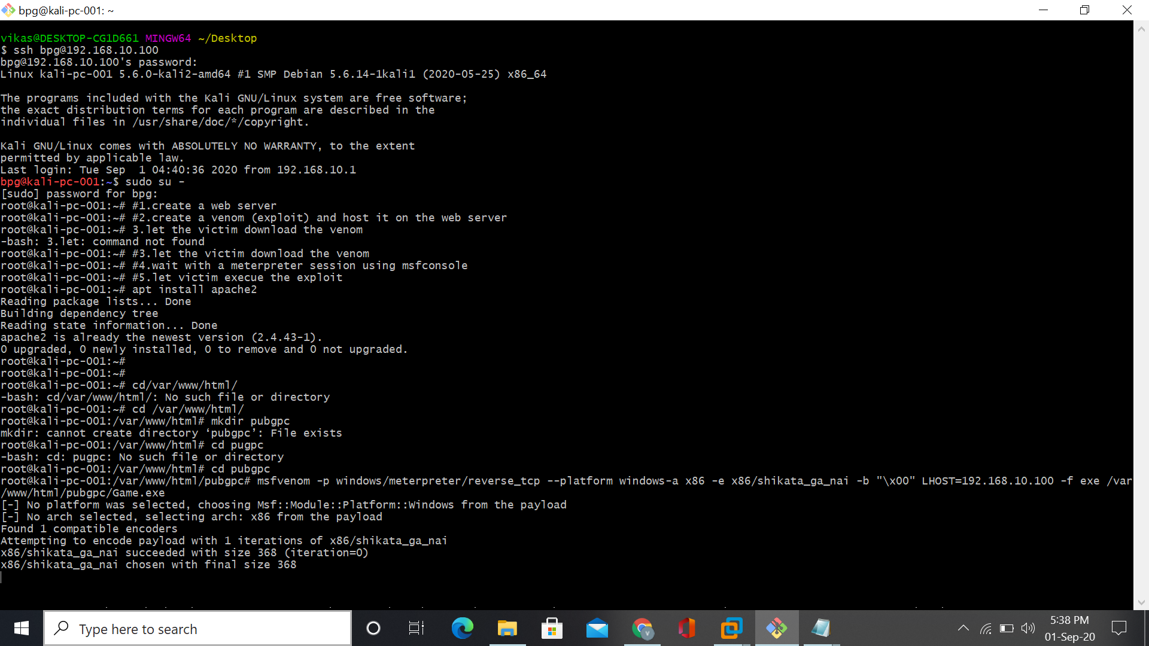

● Transfer the payload to the victim's machine.

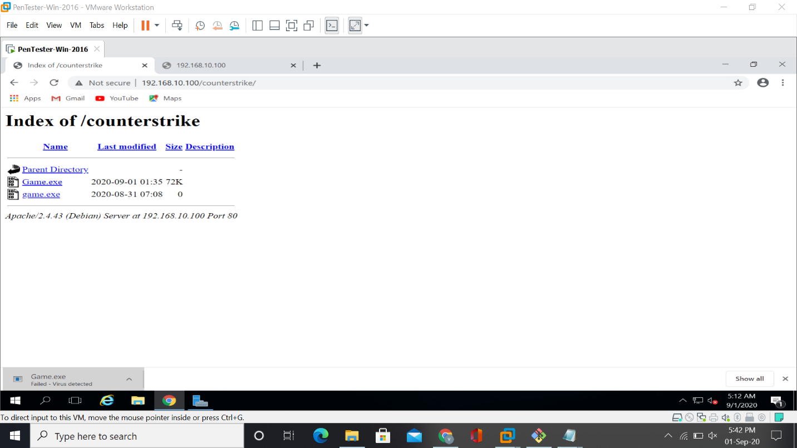

● Exploit the victim's machine.

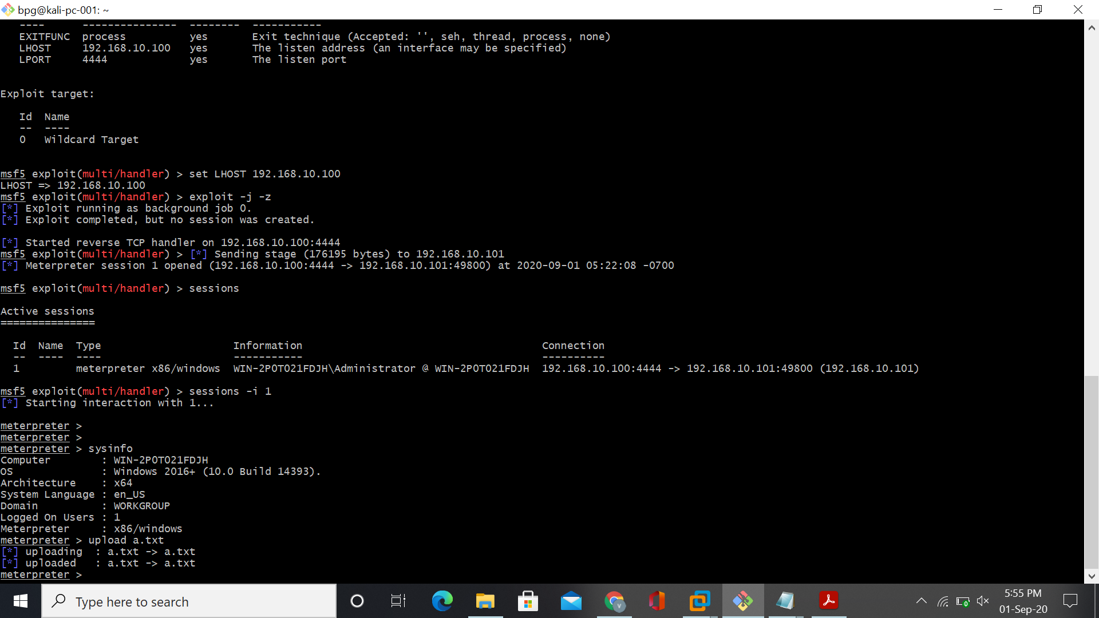

**Question 2:**

● Create an FTP server

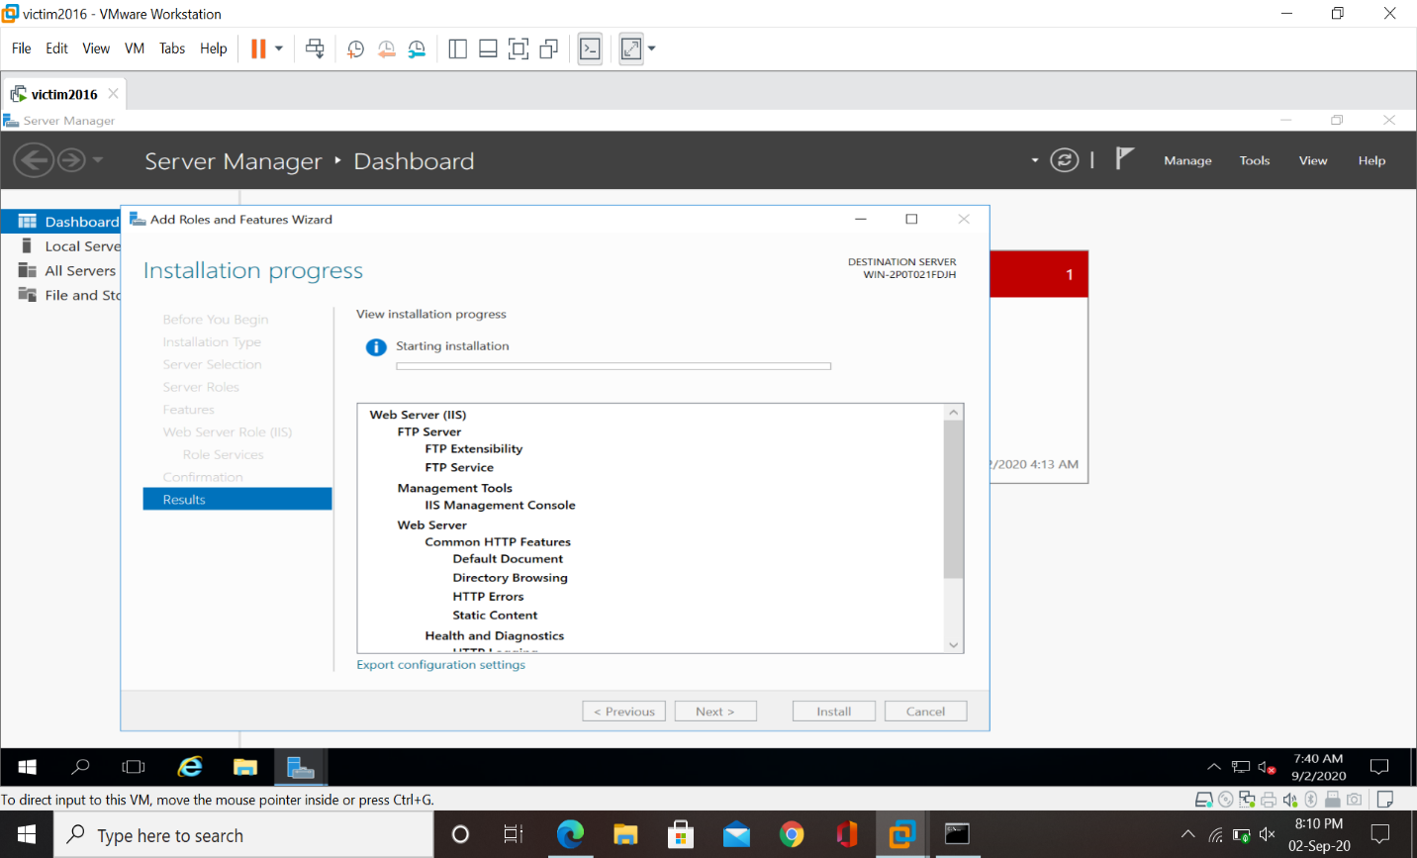

● Access FTP server from windows command prompt

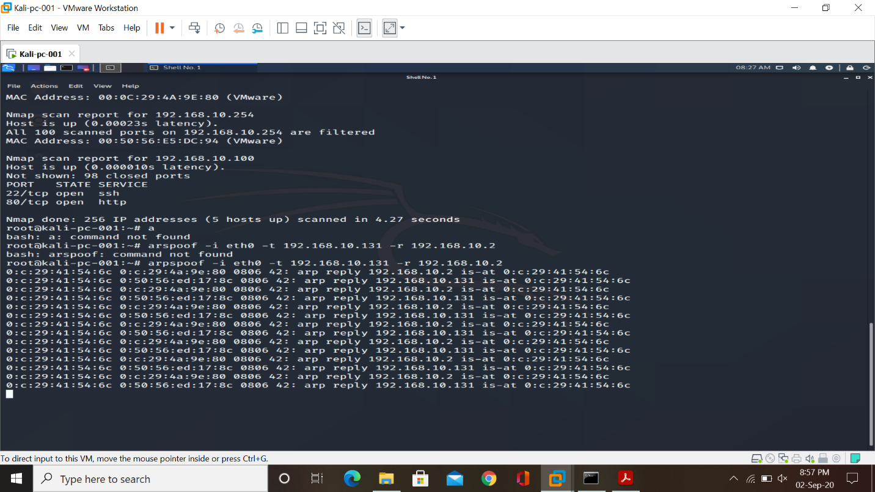

● Do an mitm and username and password of FTP transaction using wireshark and dsniff.

